CSA1708-ARTIFICIAL INTELLIGENCE
LAB EXPERIMENTS
Program 26 : Prolog Program for Fruit Color Using Backtracking
Aim
To demonstrate Prolog backtracking by finding colors for a selected fruit.
Algorithm
1. Store fruit and color pairs as facts.
2. Query a fruit with a variable for its color.
3. Prolog returns the first matching color.
4. Use backtracking to find any additional matching colors.
Program
fruit_color(apple, red).
fruit_color(apple, green).
fruit_color(banana, yellow).
fruit_color(grape, purple).
fruit_color(orange, orange).
Sample Input
?- fruit_color(apple, Color).
?- fruit_color(banana, Color).
Program Execution
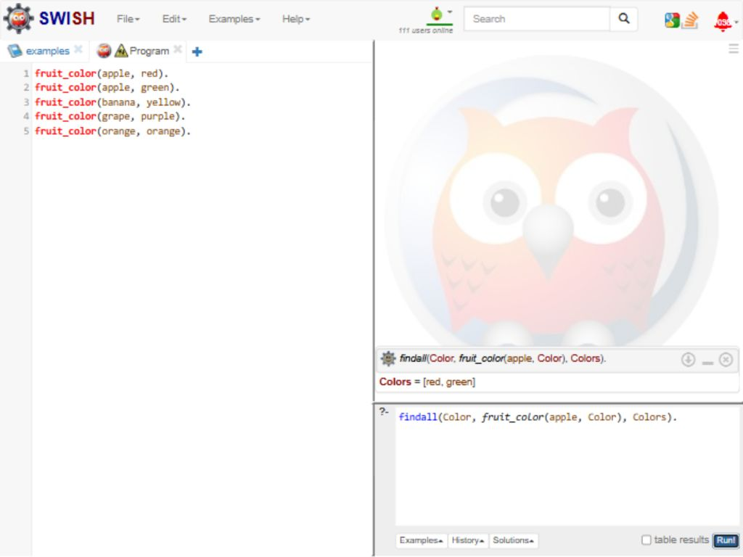
RESULT
Thus, backtracking found both stored apple colors, and the banana query returned yellow.

